Vibration of a swing (Buranko)
Dynamics and Control A
BY
THU TA ZAW

(1) The Equation of Motion about a swing

The vibration of a swing (buranko) is modeled as a pendulum with a flexible, damped rope. The rope is represented as a linear mass-spring-damper element, allowing the rope length to slightly change under the person’s weight. The calculations were done in polar coordinates.

The Free body diagram of the system
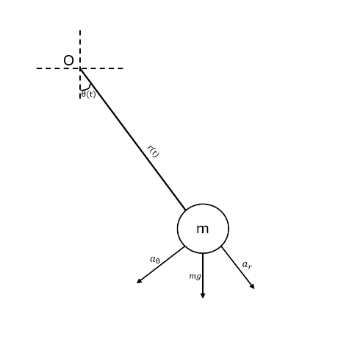
Where:
O = Origin
$L_{0}$= unstretched length of the rope
m = total mass (rider + seat)
g = gravitational acceleration
r(t) = instantaneous length of the rope (distance from pivot to mass)
$θ(t)$ = swing angle measured from the downward vertical ($θ=0$ when the mass straight down)
$$r\left(t\right)=L_{0}+x(t)$$
Where:
x(t) = the extension of the rope beyond its natural length
The cartesian position of the mass at the end is then:
$$x_{cart}(t) = r(t)sinθ(t)$$
$$y_{cart}(t) = -r(t)cosθ(t)$$
The rope is modeled as a massless spring-damper system:
- A linear spring with stiffness k (N/m),
- A viscous damper with coefficient c (N.s/m)

The free body diagram of the robe
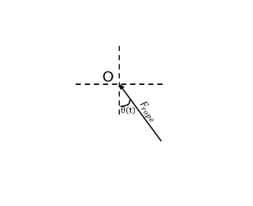
The axial force in the rope (on the mass) is:
$$F_{rope}=kx+cẋ$$
This force always acts along the rope, pulling the mass toward the pivot.
Radial acceleration:
$$a_{r}= r̈ - r{\dot{θ}}^{2}$$
Tangential acceleration:
$$a_{θ }= r\ddot{θ}+2\dot{r}\dot{θ}$$
For radial direction:
$$\sum{F_{r} = ma_{r}}$$
$$\sum{F_{r} = W_{r} + F_{rope,r}= mgcosθ - (kx + c\dot{x})}$$

$${ma}_{r}= m(r̈ - r{\dot{θ}}^{2})$$
substituting $r\left(t\right)=L_{0}+x(t)$:
$$m(\ddot{x} - (L_{0} + x){\dot{θ}}^{2}) = mgcosθ - (kx + c\dot{x})$$
The equation of motion in radial direction becomes:
$$\ddot{x} = g cosθ - \frac{k}{m}x - \frac{c}{m} \dot{x} + (L_{0} + x){\dot{θ}}^{2}$$
For Tangential direction:
$$\sum{F_{θ}}= W_{θ} + F_{rope,θ} = - mg sinθ$$
$$a_{θ}=r\ddot{θ}+2\dot{r}\dot{θ}= (L_{0} + x) \ddot{θ} + 2\dot{x}\dot{θ}$$
$$\sum{F_{θ}}=ma_{θ}$$
$$-mgsinθ=m\left(\left(L_{0} + x\right)\ddot{θ}+2\dot{x}\dot{θ}\right)$$

The Equation of motion in angular direction becomes:
$$\ddot{θ}= \frac{-gsinθ-2\dot{x}\dot{θ}}{L_{0} + x}$$
The equation of motions for the vibration of a complete mass-spring—damper swing model is:
$$\ddot{x} = g cosθ - \frac{k}{m}x - \frac{c}{m} \dot{x} + (L_{0} + x){\dot{θ}}^{2}$$
$$\ddot{θ}= \frac{-gsinθ-2\dot{x}\dot{θ}}{L_{0} + x}$$

(2) Solve the equation of motion numerically (on computer) and draw graphs of the vibration waveform
The governing equations of motion are solved numerically by using the python language as shown below.
import numpy as np
import matplotlib.pyplot as plt
from scipy.integrate import solve_ivp

# -----------------------------
# Parameters
# -----------------------------
m = 30.0 # mass [kg]
g = 9.81 # gravity [m/s^2]
L0 = 2.0 # natural rope length [m]
k = 10000.0 # spring stiffness [N/m]
c = 200.0 # damping coefficient [N·s/m]

# -----------------------------
# Equations of motion
# y = [theta, theta_dot, x, x_dot]
# -----------------------------

def swing_eom(t, y):
theta, theta_dot, x, x_dot = y

r = L0 + x # instantaneous rope length

# Avoid division by zero if r becomes too small
if r < 1e-6:
r = 1e-6

# Equations
theta_ddot = (-g * np.sin(theta) - 2.0 * x_dot * theta_dot) / r
x_ddot = g * np.cos(theta) - (k/m) * x - (c/m) * x_dot + r * theta_dot**2

return [theta_dot, theta_ddot, x_dot, x_ddot]

# -----------------------------
# Initial conditions
# -----------------------------
theta0 = 0.3 # initial angle [rad] ~ 17 deg
theta_dot0 = 0.0 # initial angular velocity [rad/s]
x0 = 0.0 # initial rope extension [m]
x_dot0 = 0.0 # initial extension rate [m/s]

y0 = [theta0, theta_dot0, x0, x_dot0]

# -----------------------------
# Time span for simulation
# -----------------------------
t_start = 0.0
t_end = 20.0 # simulate 20 seconds
t_eval = np.linspace(t_start, t_end, 4000) # output times

# -----------------------------
# Solve ODE
# -----------------------------
sol = solve_ivp(
swing_eom,
(t_start, t_end),
y0,
t_eval=t_eval,
method="RK45",
rtol=1e-8,
atol=1e-8
)

t = sol.t
theta = sol.y[0]
theta_dot = sol.y[1]
x = sol.y[2]
x_dot = sol.y[3]

# -----------------------------
# Compute trajectory in Cartesian coordinates
# -----------------------------
r = L0 + x
x_cart = r * np.sin(theta)
y_cart = -r * np.cos(theta)

# -----------------------------
# Plot results
# -----------------------------

plt.figure(figsize=(10, 6))
plt.plot(t, theta)
plt.xlabel("Time [s]")
plt.ylabel("Angle θ [rad]")
plt.title("Swing Angle vs Time")
plt.grid(True)

plt.figure(figsize=(10, 6))
plt.plot(t, x * 1000) # mm for visibility
plt.xlabel("Time [s]")
plt.ylabel("Rope Extension x [mm]")
plt.title("Rope Extension vs Time")
plt.grid(True)

plt.figure(figsize=(6, 6))
plt.plot(x_cart, y_cart)
plt.xlabel("x [m]")
plt.ylabel("y [m]")
plt.title("Trajectory of the Mass")
plt.axis("equal")
plt.grid(True)

The following results are the illustration of the results of constant swing function.
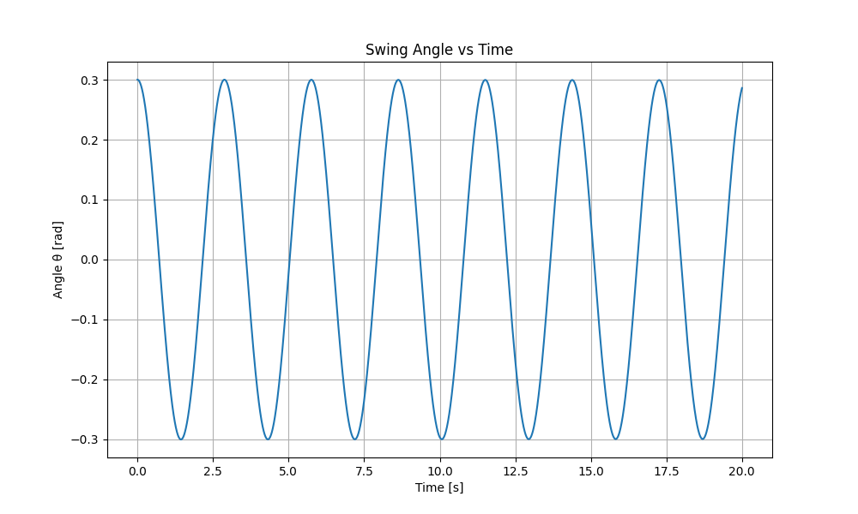
Fig.1 Swing angle vs time graph for swing angle of 17 Degree
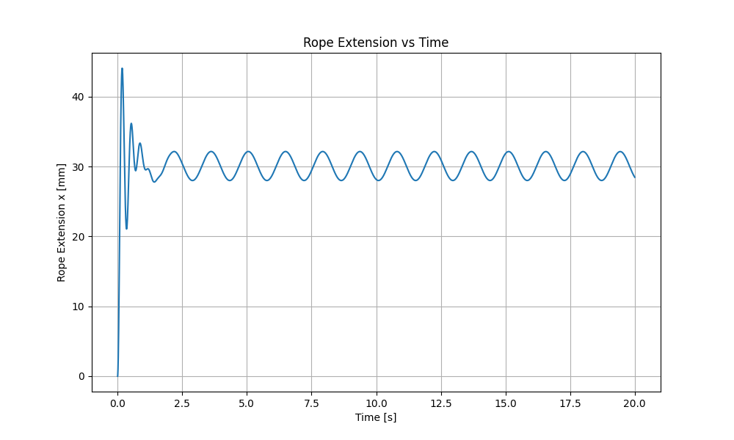
Fig.2 Rope Extension vs time graph for swing angle of 17 Degree
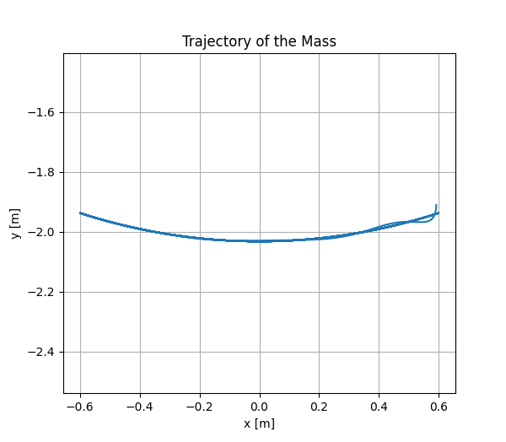
Fig.3 Trajectory of the mass graph for swing angle of 17 Degree

Figure 1 illustrates the changes in swing angle depending on the time. By analyzing the graph, the swing angle value is getting smaller by time. Figure 2 shows the rope extension caused by the person during the swing. It starts with high oscillations values and eventually gets smaller by time. Figure 3 demonstrates the trajectory of the mass, and it seems to be consistent with throughout the time for the current swing function.
(3) Investigate how the vibration changes depending on how to swing on the swing (change the function of swing motion). Including Result, calculation method, program, discussion.

The swing function has been changed by adding stop phase between the swing, which means the swing moves freely for a while and then it holds for a while before swing again. The python code for the improved swing function is shown as follows.
import numpy as np
import matplotlib.pyplot as plt
from scipy.integrate import solve_ivp

# -----------------------------
# Parameters
# -----------------------------
m = 30.0 # mass [kg]
g = 9.81 # gravity [m/s^2]
L0 = 2.0 # natural rope length [m]
k = 10000.0 # spring stiffness [N/m]
c = 200.0 # radial damping coefficient [N·s/m]

# "Stop & swing" control parameters
swing_duration = 3.0 # seconds of free swinging
stop_duration = 2.0 # seconds of stopping/holding
cycle_duration = swing_duration + stop_duration

# Strong "controller" to stop the swing (tangential direction)
k_stop = 50.0 # angular stiffness during stop [N·m/rad approx]
c_stop = 20.0 # angular damping during stop [N·m·s/rad approx]

def mode_function(t):
"""
Return 'swing' or 'stop' depending on time.
One cycle = [0, swing_duration) -> swing
[swing_duration, cycle_duration) -> stop
and then repeat periodically.
"""
tau = t % cycle_duration
if tau < swing_duration:
return "swing"
else:
return "stop"

# -----------------------------
# Equations of motion
# y = [theta, theta_dot, x, x_dot]
# -----------------------------
def swing_eom(t, y):
theta, theta_dot, x, x_dot = y

r = L0 + x # instantaneous rope length
if r < 1e-6:
r = 1e-6

# Base (free) dynamics
theta_ddot_free = (-g * np.sin(theta) - 2.0 * x_dot * theta_dot) / r
x_ddot = g * np.cos(theta) - (k/m) * x - (c/m) * x_dot + r * theta_dot**2

# Determine mode: "swing" or "stop"
mode = mode_function(t)

if mode == "swing":
# Free swing, no extra control
theta_ddot = theta_ddot_free
else:
# Stop mode: add strong restoring + damping torque toward theta = 0
# This is like someone actively holding/braking the swing.
#
# Extra tangential "control" term:
# tau_ctrl ~ -k_stop * theta - c_stop * theta_dot
# -> contributes as +tau_ctrl / (m * r) to tangential acceleration.
tau_ctrl = -k_stop * theta - c_stop * theta_dot
a_theta_ctrl = tau_ctrl / (m * r)

theta_ddot = theta_ddot_free + a_theta_ctrl

return [theta_dot, theta_ddot, x_dot, x_ddot]

# -----------------------------
# Initial conditions
# -----------------------------
theta0 = 0.4 # initial angle [rad]
theta_dot0 = 0.0 # initial angular velocity [rad/s]
x0 = 0.0 # initial rope extension [m]
x_dot0 = 0.0 # initial extension rate [m/s]

y0 = [theta0, theta_dot0, x0, x_dot0]

# -----------------------------
# Time span for simulation
# -----------------------------
t_start = 0.0
t_end = 30.0 # longer to see several stop/swing cycles
t_eval = np.linspace(t_start, t_end, 6000)

# -----------------------------
# Solve ODE
# -----------------------------
sol = solve_ivp(
swing_eom,
(t_start, t_end),
y0,
t_eval=t_eval,
method="RK45",
rtol=1e-8,
atol=1e-8
)

t = sol.t
theta = sol.y[0]
theta_dot = sol.y[1]
x = sol.y[2]
x_dot = sol.y[3]

# -----------------------------
# Compute trajectory in Cartesian coordinates
# -----------------------------
r = L0 + x
x_cart = r * np.sin(theta)
y_cart = -r * np.cos(theta)

# -----------------------------
# Plot results
# -----------------------------
plt.figure(figsize=(10, 5))
plt.plot(t, theta)
plt.xlabel("Time [s]")
plt.ylabel("Angle θ [rad]")
plt.title("Swing Angle vs Time (Stop & Swing Alternating)")
plt.grid(True)

plt.figure(figsize=(10, 5))
plt.plot(t, x * 1000)
plt.xlabel("Time [s]")
plt.ylabel("Rope Extension x [mm]")
plt.title("Rope Extension vs Time (Stop & Swing Alternating)")
plt.grid(True)
plt.show()

The results are illustrated as follows.
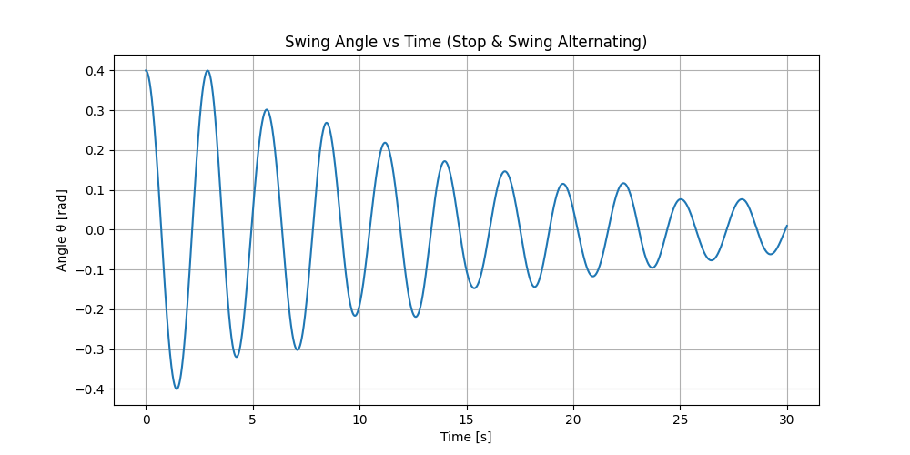
Fig.4 Swing angle vs time (stop and swing alternating)
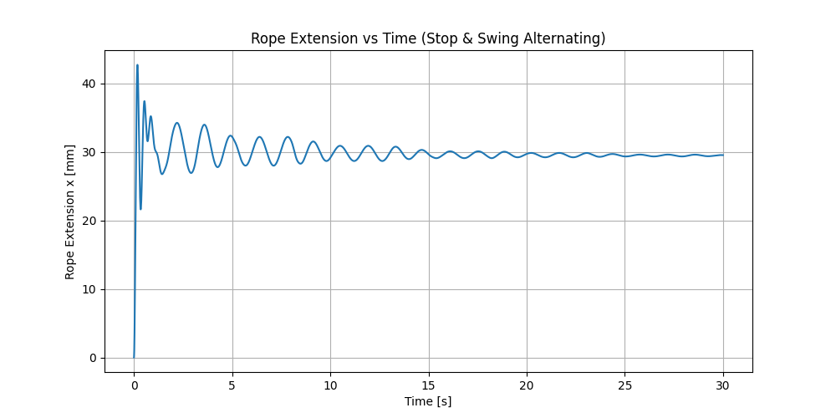
Fig.5 Rope extension vs time (stop and swing alternating)

Figure 4 illustrates changes in swing angle for the swing-and-stop swing function. It is noticed that the swing angle gradually decreases overtime.
Figure 5 illustrates the rope extension throughout the time, and it is found that the rope extension is maximum at the start of the swing and it gradually smaller when approaching towards the end.
Since the k value is much higher when compared to c, the overall system is assumed to be stable and there is only minimum energy loss. Furthermore, the higher k value could maintain the structural integrity of the rope and prevent the bouncing effect of the rope to make the swing stable and prevent the rope from breaking the rope.

THU TA ZAW
2415121095

